Do Must-Access PDMPs Affect Pain and Disability?

Martha Wetzel

ECON 771

Advisor: Courtney Yarbrough

# Introduction

The Centers for Disease Control and Prevention (CDC) estimate that approximately 50 million adults in the US suffer from chronic pain, with 19.6 million of them experiencing high-impact chronic pain that limits life or work activities most days (Dahlhamer, Lucas et al. 2018). The economic burden of chronic pain was estimated to be between $560 billion and $635 billion per year in the Institute of Medicine’s foundational report on pain in 2011 (Institute of Medicine 2011). The human cost is also high, with disability and chronic pain being associated with suicidal behavior in older adults (Fässberg, Cheung et al. 2016).

Concurrently, unchecked proliferation of opioids has led to a drug epidemic of unprecedented proportions, with nearly 50,000 Americans dying in 2019 from a drug overdose involving an opioid (National Institute on Drug Abuse 2021). Together, chronic pain and opioid overuse disorder are a syndemic, meaning that they are co-occurring epidemics with synergistic interactions (Fornili 2018). As a consensus study report from the National Academies of Science, Engineering, and Medicine explains, “The ongoing opioid crisis lies at the intersection of two substantial public health challenges—reducing the burden of suffering from pain and containing the rising toll of the harms that can result from the use of opioid medications” (National Academy of Sciences 2017).

Although the National Academies recommend a multi-pronged approach that addresses both pain and opioids, popular and political attention has focused more narrowly on restricting the opioid supply (Goodin 2018, Gross and Gordon 2019). Commonly passed opioid-related legislation includes opioid prescribing limits and prescription drug monitoring programs (PDMPs) (Davis, Lieberman et al. 2019, Horwitz, Davis et al. 2021). The focus on reducing supply has elicited editorials in medical journals expressing concern about abandoning pain patients (Webster 2014, Rubin 2019). In the informal literature, there is an emerging narrative that decreasing opioid prescribing has harmed patients with chronic pain (Gleason 2014, Anson 2017, Human Rights Watch 2018) and even contributed to suicides among pain patients (Szalavitz 2022). These fears are also expressed in commentaries in the formal literature, such as case reports of suicides in chronic pain patients (Webster 2014, Goodin 2018). Scientific study of harms among chronic pain patients in the aftermath of opioid restrictions has been more limited (Antoniou, Ala-Leppilampi et al. 2019). Given the prevalence and disabling potential of chronic pain, this is an important area for research. This study aims to contribute to this literature by measuring the relationship between must-access PDMPs and frequent pain, severe/disabling pain, and functional status in older adults with and without a history of pain.

## Policy Review

Prescription drug monitoring program (PDMP) laws create statewide databases documenting filled prescriptions for controlled substances, which can then be checked by both prescribers and pharmacists. In many states, use of the PDMP is optional, but a growing number of states are requiring prescribers to check the PDMP prior to prescribing opioids (Horwitz, Davis et al. 2021). There are multiple proposed mechanisms through which PDMPs can affect prescriber behavior (Finley, Garcia et al. 2017). First, the presence of a PDMP can encourage prescribers to reduce prescribing to patients suspected of opioid misuse or diversion. Second, if PDMPs impose costs to prescribers in terms of time and reputational effects, then must-use PDMPs may have a “chilling effect” (Reisman, Shenoy et al. 2009, Ringwalt, Schiro et al. 2015, Finley, Garcia et al. 2017).

Evaluations of the effects of these programs have primarily focused on opioid prescribing and opioid overdose deaths (Finley, Garcia et al. 2017, Fink, Schleimer et al. 2018, Puac-Polanco, Chihuri et al. 2020). Although studies on the effect of PDMPs on opioid prescribing outcomes have yielded mixed results, a recent review showed that 11 out of 16 reviewed studies showed a decrease in prescribing, with the clearest results coming from studies of must-access policies (Puac-Polanco, Chihuri et al. 2020). Subsequent work has showed that heterogeneity in the effective dates for PDMPs used by researchers explains some of the older divergent findings and established a commonly accepted set of policy implementation dates (Horwitz, Davis et al. 2021). This work has also reiterated the finding that must-access PDMPs are associated with a decrease in the percentage of beneficiaries receiving an opioid prescription (Horwitz, Davis et al. 2021). Similarly, a rigorous analysis by Buchmueller and Carey (2018) found decreases in a number of opioid-related measures among Medicare Part D beneficiaries, including measures of misuse and the probability of taking opioids. However, they also found some evidence of anticipatory effects of the policies (Buchmueller and Carey 2018).

The literature on differential effects of must-access PDMPs is in early stages. One study found no effect on receipt of opioid prescriptions of must-access PDMPs on disabled individuals (Ozturk, Hong et al. 2021); however, this study has limited external validity due to its focus on a small subset of disabling conditions and a time frame that predates 80 percent of must-access PDMPs. In contrast, Buchmueller and Carey found that the bulk of the policy effects were concentrated among low-income disabled beneficiaries (Buchmueller and Carey 2018).

While a substantial body of literature evaluates the effect of must-access PDMPs on prescribing outcomes, literature exploring the relationship between must-access PDMPs and downstream effects relating to quality of life is more limited. Despite recommendations from the National Academies and the National Pain Strategy to prioritize research on pain, only a handful of studies evaluate pain and functional status outcomes (Kilby 2015, Antoniou, Ala-Leppilampi et al. 2019). One qualitative study conducted focus groups with patients who took opioids following several opioid-related policy changes in Ontario, including formulary changes and a PDMP. Pain patients reported increased stigmatization, deteriorating relationships with providers, and increased difficulties in handling their health and pain (Antoniou, Ala-Leppilampi et al. 2019). In terms of quantitative work, one study showed an association between must-access PDMP laws and indicators of disability among people who experienced acute pain related to a surgery or injury (Wetzel, von Esenwein et al. 2021). To our knowledge, research on disability among chronic pain patients following implementation of opioid restricting policies is lacking.

## Theory and Medical Research

For patients with chronic pain conditions, pain management health care services can be an important input to health. Conceptually, it is useful to subdivide pain management services into opioids and non-opioid based treatments, which include physical therapy, cognitive behavioral therapy, and non-opioid pharmacology. As described above, the literature suggests that opioid prescribing has decreased following the implementation of must-access PDMP laws (Puac-Polanco, Chihuri et al. 2020). For patients using opioids medically for pain treatment, if opioid therapy decreased while other inputs remained unchanged, we may expect to see a corresponding increase in pain. If non-opioid therapy is substituted for opioid therapy and functions effectively as a substitute good, increases in pain may not occur. Clinical trial evidence suggests that for some conditions, non-opioid pharmacological treatments are no different than opioid treatments for pain control (Poonai, Datoo et al. 2017, Krebs, Gravely et al. 2018). However, the assumption that real world implementation mirrors the clinical study protocols is likely too strong; despite evidence of equivalence of opioid and non-opioid therapy for many acute conditions, one study found increased disability in a post-surgical population under must-access PDMP laws. This could be a function of either different types of pain treatment not being perfect substitutes, or the reduction in opioid therapy not being accompanied by a change in the non-opioid therapy.

In 2016, the CDC synthesized the existing research on chronic pain treatments into formal guidelines, which specified that opioids should not be a first-line treatment for chronic pain (Dowell, Haegerich et al. 2016). This is because the risks associated with opioids are substantial and the benefits of long-term use are not clear (Dowell, Haegerich et al. 2016). Thus, patients presenting with new chronic pain may achieve better functioning if they present in opioid-hesitant settings. Considerations for existing chronic pain patients in settings of increasing opioid-hesitancy are different than those for new patients. It’s estimated that 3-4% of Americans receive long-term opioid therapy (Dowell, Haegerich et al. 2016). Of adults with certain disabilities such as cerebral palsy, spinal cord injury, and rheumatoid arthritis, approximately 15% used opioids for an extended period of time (Ozturk, Hong et al. 2020). Both economic theory and medical research suggests that legacy chronic pain patients may struggle as the norms around pain care and opioid prescribing change. Due to status quo bias, patients may value their existing treatment plans more highly than they would value acquiring the same treatment plan if they did not already have it. Furthermore, as opioid began to fall out of favor, some chronic pain patients on long-term opioid therapy have been forced to taper down their opioid usage or completely discontinue opioid therapy, regardless of the patients’ preferences (Rubin 2019). Higher rates of death due to unintentional overdose and suicide have been documented in patients after discontinuing long-term opioid therapy compared with patients continuing long-term therapy (Oliva, Bowe et al. 2020). Evidence suggests that implementation of robust PDMPs is associated with reductions in long-term opioid use for privately insured adults under the age of 65, although results differed for older adults insured via Medicare Advantage (Bao, Zhang et al. 2021). An additional difficulty for legacy patients on long-term opioid therapy is access to care. A study of primary care clinics in Michigan found that 40% refused to accept new patients on long-term opioid therapy (Lagisetty, Healy et al. 2019). Thus, for legacy patients, pressure to taper opioid doses and difficulty accessing care may both contribute to the gray literature reports that these are experiencing increased disability and pain in opioid-hesitant settings.

# Methodology

## Data Sources

Individual level data comes from the Health and Retirement Study (HRS), which is an ongoing longitudinal survey of more than 37,000 older adults in US managed by the University of Michigan and funded by the National Institute on Aging and the Social Security Administration (Sonnega, Faul et al. 2014, Health and Retirement Study 2017). The panel includes adults aged 50 and above, along with their spouses. New cohorts are added every six years (Sonnega, Faul et al. 2014). Response rates are generally between 75.3 to 93.0 percent. The sampling strategy is a multi-stage area probability design based on geographic location and demographic characteristics (Sonnega, Faul et al. 2014). Follow-up surveys are conducted with participants every two years. The HRS is one of the longest-running studies that includes a suite of questions focusing on disability, functioning, and pain (Agree and Wolf 2017). This makes it well-suited for answering the study question. For this analysis, we use HRS data from all waves 2002-2018, which includes surveys conducted 2002-2019. Although the HRS began in 1992, the first physician must-access PDMP meeting our criteria for inclusion was implemented in 2012. Beginning in 2002 allows for five waves worth of pre-intervention measurements and avoids the changes made to the survey between 2000 and 2002.

The independent variable of interest is the presence of a prescriber must-access PDMP law. We define these must-access PDMP laws as those that require the prescriber to check the PDMP prior to prescribing an initial opioid and at regular intervals thereafter. We do not consider laws that allow for exceptions for clinician judgement, established patients, or prescriptions under 30 days supply to be must-access laws. Furthermore, in a handful of states, the law theoretically went into effect prior to the electronic database system being fully functional, and implementation was effectively delayed (e.g., Pennsylvania). In these cases, we use the date that the system was functional instead of the date the program was intended to begin. In general, our PDMP law data set is similar to that used by Horowitz, Davis et al. and RAND (Horwitz, Davis et al. 2021, RAND-USC Schaeffer Opioid Policy Tools and Information Center 2021). However, some differences exist given the stricter criteria of our must-access PDMP definition. During the time period 2002-2019, 33 states implemented a must-access PDMP law (Appendix).

## Sample

Both the full sample and a subsample with a history of pain were identified. The full sample includes all responses except for those missing a state location or reporting that the respondent was currently residing in a US territory. In addition, a subsample of respondents who answered “yes” to the question “Are you often troubled with pain?” was identified for three different time periods: the 2008 or 2010 wave, 2010 or 2012 wave, and 2012 or 2014 wave.

## Outcomes

The primary outcome of interest is frequent pain. Frequent pain was measured using the question “Are you often troubled with pain,” which is a yes/no response question. Several secondary outcomes will also be considered, including severe or disabling pain, a count of functional limitations, and difficulty finding a clinician. Respondents who answer yes to the troubled with pain question are asked follow-up questions, and the severe or disabling pain measure is derived from these follow up questions. If an individual chooses “moderate” or “severe” for “How bad is the pain most of the time?” or responds yes to “Does the pain make it difficult for you to do your usual activities such as household chores or work,” the individual is considered to have severe or disabling pain (Li, Dworkin et al. 2021). The count of functional limitations is based on the HRS question G013, which summarizes responses to a set of activity limitation questions, such as ability to job a mile and ability to climb a set of stairs.

Opioid use represents an important mechanism in this study. However, questions specific to pain medication were only introduced in the 2016 survey wave. Prior to 2016, two potentially relevant medication questions were asked: “Do you regularly take prescription medications?” and “[Do you regularly take prescription medications …] For pain in your joints or muscles?” Another potential mechanism is an unwillingness of clinicians to take on pain patients. One question on the HRS captures this mechanism: “In the last two years, did you have any trouble finding a general doctor or provider who would see you?” These three questions will be analyzed as potential mechanisms.

## Empirical Approach

Our empirical approach begins with a classic difference-in-difference two-way fixed effects model:

$$y_{it}=β_{0}+β_{1}pdmp_{it}+states_{it}β_{3}+years_{it}β_{4}+ϵ_{it}$$

Where *pdmpit* is a binary indicator equal to 1 if the respondent lives in a state with a must-access PDMP and the interview was conducted after the PDMP implementation date, and **Xit** represents a vector of control variables for individual *i* at time *t.* Linear probability models are employed for the binary outcomes. Standard errors were clustered at the state level. As a sensitivity check, this model was also run with respondent-level fixed effects in place of the state-level fixed effects. A key identifying assumption of the difference-in-difference approach is that the treated and untreated units have parallel trends prior treatment. As a check on this assumption, event study models were run and reviewed.

Recent literature on two-way fixed effects models for difference-in-difference analysis has identified several weaknesses of the method, including unpredictable results in the presence of heterogeneity across treated units and negative weights stemming from so-called “forbidden comparisons” (Roth, Sant'Anna et al. 2022). We employed several methods to explore these potential issues. First, we ran separate event study regressions for each of our three treatment cohorts. Treated states were grouped into cohorts by the survey wave during which they implemented their must-access PDMP. This yielded three cohorts: 2012-2013 adopters, 2014-2015 adopters, and 2016-2017 adopters. For each of these cohorts, the comparison group was limited to never-adopters. As a sensitivity check, post-study period late-adopters (i.e., states implementing a policy in 2020 or later) were added to the comparison group. While this approach allows for heterogeneity across treatment cohorts and ensures that the treatment effect estimates are limited to comparisons between treated and never-treated groups, it does not produce aggregated estimates. Thus, we also aggregated event studies using the Sun and Abraham (Sun and Abraham 2021) and Callaway and Sant’Anna (Callaway and Sant’Anna 2021) approaches.

The HRS is conducted in two-year waves, with the majority of interviews taking place during even years. Given the nature of this two year cycle, we tested two approaches for counting policy time: survey waves and calendar time. For the survey wave counting approach, all interviews and policies were assigned to a survey wave, and interviews in treated states taking place during the same wave as policy implementation were assigned *t=0*. A drawback of this approach is that the t=0 period does not have a clean interpretation, since the interview may have taken place either shortly before or after the policy implementation. However, since prior research has shown some anticipatory effects of the must-access PDMP policies (Buchmueller and Carey 2018), this grouping may be appropriate. The second approach counts time in two-year increments relative to the actual date of interview. In treatment states, *t=0* if the interview takes place in the two years following the policy implementation. In all specifications, interviews in never-implementing states were assigned *t=-1*.

Sensitivity checks using the HRS survey weights will be conducted and alternative models including respondent-level fixed effects will be run.

# Preliminary Results and Discussion

After excluding responses missing state of residence or from respondents residing in a US territory, 172,724 responses representing 34,431 individuals remained. A summary of individual characteristics and types of persistent pain reported is provided in Table 1. The median age is 66 and 36.4% of responses reported being frequently troubled by pain. Approximately 15,000 observations (9.0%) were identified as taking place after a must-access PDMP law was implemented in the respondent’s state.

Table : Response Characteristics

| **Variable** | **Level** | **N** | **Overall N=172,724** |
| --- | --- | --- | --- |
| Age  *Median (Q1, Q3)* |  | 172460 | 66 (58, 75) |
| Married | Married | 172692 | 102153 (59.15%) |
| Not Married | 70539 (40.85%) |
| Count of Household Members  *Median (Q1, Q3)* |  | 172524 | 0 (0, 1) |
| Insurance | Private | 172724 | 50641 (29.32%) |
| Medicare | 81437 (47.15%) |
| Medicaid | 17439 (10.10%) |
| Tricare/Military | 9499 (5.50%) |
| None | 13708 (7.94%) |
|  |  |  |  |
| Gender | Female | 172723 | 101424 (58.72%) |
| Male | 71299 (41.28%) |
|  |  |  |  |
| Race | White | 172304 | 128566 (74.62%) |
| Black | 30637 (17.78%) |
| Other | 13101 (7.60%) |
|  |  |  |  |
| Hispanic | Hispanic | 172492 | 21068 (12.21%) |
| Non-Hispanic | 151424 (87.79%) |
| Education | Less than High School | 172724 | 35311 (20.44%) |
| High School | 88317 (51.13%) |
| Some College | 11549 (6.69%) |
| 4-year College or More | 37547 (21.74%) |
|  |  |  |  |
| Arthritis | No | 172436 | 72816 (42.23%) |
| Yes | 99620 (57.77%) |
|  |  |  |  |
| Back Pain | No | 85626 | 51914 (60.63%) |
| Yes | 33712 (39.37%) |
|  |  |  |  |
| Persistent Headaches | No | 85676 | 76491 (89.28%) |
| Yes | 9185 (10.72%) |
|  |  |  |  |
| Must-Access PDMP | No | 172724 | 157186 (91.00%) |
| Yes | 15538 (9.00%) |
|  |  |  |  |
| Medical Marijuana Law | No | 172724 | 119149 (68.98%) |
| Yes | 53575 (31.02%) |
|  |  |  |  |
| Interview Wave Year | 2002 | 172724 | 18122 (10.49%) |
| 2004 | 20072 (11.62%) |
| 2006 | 18399 (10.65%) |
| 2008 | 17146 (9.93%) |
| 2010 | 21961 (12.71%) |
| 2012 | 20475 (11.85%) |
| 2014 | 18659 (10.80%) |
| 2016 | 20830 (12.06%) |
| 2018 | 17060 (9.88%) |

## Full Population

The traditional two-way fixed effects models yielded positive treatment effects, as shown in Table 2. The base model estimated that must-access PDMPs are associated with a 1.5% increase in reports of being frequently troubled by pain. When respondent-level fixed effects were substituted for state-level fixed effects, the estimate remained positive, but became statistically insignificant.

Table : Effect of Must-Access PDMPs on Frequent Pain

|  | **Model 1** | **Model 2** | **Model 3** |
| --- | --- | --- | --- |
| Current PDMP | 0.015** | 0.013* | 0.007 |
|  | (0.005) | (0.006) | (0.005) |
| Num.Obs. | 172315 | 137839 | 172315 |
| R2 | 0.009 | 0.010 | 0.577 |
| Std.Errors | by: state | by: state | by: respondent |
| FE: Interview Year | X | X | X |
| FE: States | X | X |  |
| FE: Respondent |  |  | X |
| *Notes: Coefficients are from a linear probability model of frequent pain. Standard errors in parentheses. Model 2 excludes the Western states, which did not have any must-access PDMP activity during the measurement period.*  *\* p-value < 0.05, ** <0.01, *** < 0.001* | | | |

The parallel trend tests yielded mixed results. Figure 1 displays the results of the event study, in which time is measured in two-year increments relative to the exact interview date. This figure shows the treatment group estimates over time relative to the comparison group and suggests a pre-existing trend toward increased pain in the treatment group starting approximately 5-6 years prior to the implementation of a must-access PDMP policy. The results of the Sun and Abraham event study method yielded nearly identical results. In contrast, the models in which time was measured in survey waves do not show any evidence of a pre-existing trend.[1]

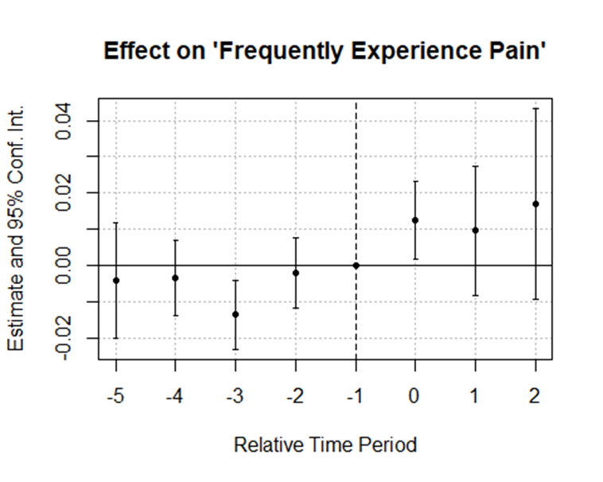

Figure : Trend Test for Frequent Pain

These differing trend results are concerning, and the next steps will be an attempt to understand what is driving the differing results. The next step will simply be to identify respondents who are categorized differently in the two time-counting methods and determine if there are certain states that appear to be consistently re-categorized. The cohort-specific event studies were, in general, imprecisely estimated, and none showed significant point estimates in the post-period. However, the 2012-2013 adopters may be the primary driver of the pre-period trend. A leave-one-out analysis may be helpful if this pre-existing trend is driven largely by a single state, particularly if that state is one that is categorized differently by the two time counting methods. Additionally, all estimates reported here do not use survey weights, and I need to check if applying the survey weights changes the results.

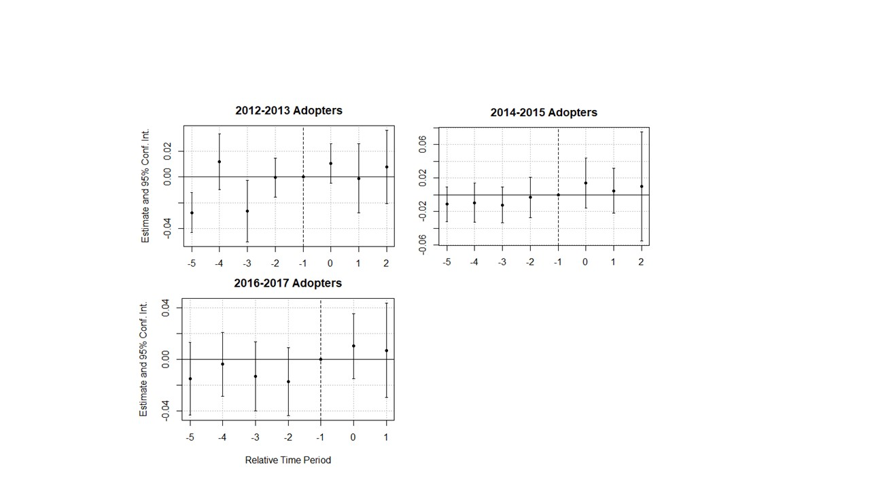

Figure : Cohort-Specific Event Studies

I also am considering what fixed effects are most appropriate. The model with individual fixed effects demonstrated that much of the variation in outcomes is between-individual rather than within-individual. Do the pre-trends matter if the results are not robust to the inclusion of individual fixed effects? Furthermore, I included interview year fixed effects in all models, and I am wondering if survey wave fixed effects would be more appropriate. Many of the respondents interviewed in odd years are respondents who were not originally available for interviews during the initial survey fielding. These respondents may systematically differ from respondents who were initially available. Year fixed effects may be absorbing some of this variation.

Finally, I have several secondary outcomes and mechanisms that I have not fully explored yet. I did a cursory review of the severe pain and functional status outcomes, and both were imprecisely estimated. I think it makes the most sense to focus on understanding the divergent results produced by the different analyses on the basic pain outcome before doing beginning work on the remaining outcomes.

## Subpopulation Analysis

The subpopulation analyses included between 25,000 and 27,000 respondents who had reported frequently experiencing pain in either of the two prior surveys waves. The estimates for the severe or disabling pain outcome from the two-way fixed effects models were positive and similar in magnitude for the 2014-2015 and 2016-2017 cohorts, but insignificant. However, the estimate for the 2012-2013 cohort was negative. Estimates for the two-way fixed effects models are shown in Table 3 and event studies are provided in Figure 3.

The next steps on this section are limited, because it looks like the answer is a more straightforward no effect or potentially a very small effect with substantial variation across treated units. However, I should probably rerun the models using the survey wave timings just to be sure there are no big changes.

Table : Effect on Severe or Disabling Pain, Subpopulation Analysis

|  | **2012-2013 Cohort** | **2014-2015 Cohort** | **2016-2017 Cohort** |
| --- | --- | --- | --- |
| Current PDMP | -0.007 (0.008) | 0.021 (0.016) | 0.023 (0.017) |
| Num.Obs. | 25054 | 25878 | 27325 |
| R2 | 0.027 | 0.031 | 0.033 |
| Std.Errors | by: state | by: state | by: state |
| FE: State | X | X | X |
| FE: Interview Year | X | X | X |

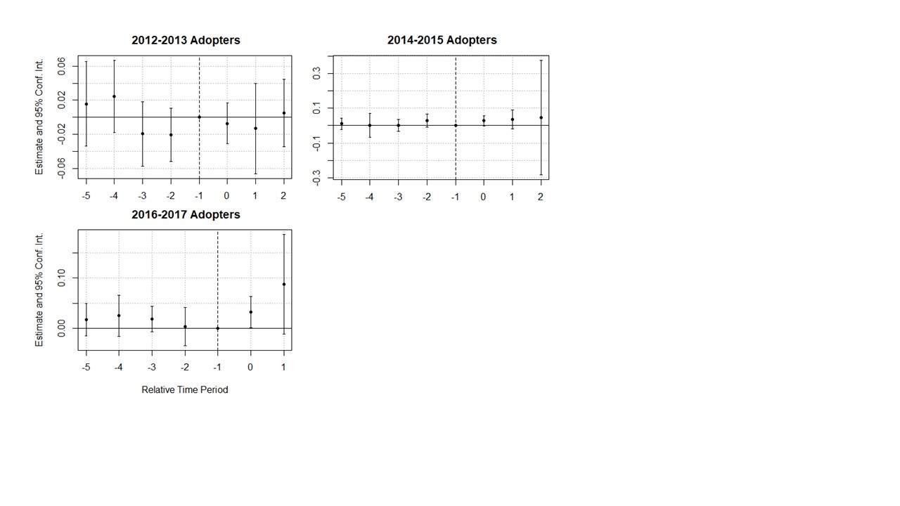

Figure : Effect on Severe Pain - Subpopulation Event Studies

# Conclusion

## Formal Conclusion

Estimate of the effect of must-access PDMPs are sensitive to changes in model specification and timing. The effects appear to be heterogenous across treatment cohorts, with earlier treatment cohorts potentially diverging from later treatment cohorts. There is some evidence of a pre-period trend toward increasing pain, beginning earlier than previously identified pre-period trends in opioid prescribing (Buchmueller and Carey 2018). Such a pre-period trend could reflect changing attitudes toward pain and opioids that pre-dates the implementation of a must-access PDMP. Results for the subpopulation that previously reported frequent pain are imprecisely estimated. Reports of worsening pain among pain patients in the wake of policy changes may represent concerns of too few individuals to leave a signal in the HRS data.

## Real Talk Conclusion

Depending on how I treat timing and whether I include respondent-level fixed effects, there is possibly no effect of must-access PDMPs on frequent pain, an effect that is actually just an extension of a pre-existing trend toward increased pain in treated states, or an effect that begins only after must-access PDMP implementation. Chaos! I hope this isn’t being graded on presenting a coherent narrative because I clearly don’t have one yet.

# Works Cited

Agree, E. M. and D. A. Wolf (2017). "Disability Measurement in the Health and Retirement Study." Forum Health Econ Policy **21**(1).

Anson, P. (2017). "Survey Finds CDC Opioid Guidelines Harming Patients." Retrieved March 15, 2017, from <https://www.painnewsnetwork.org/stories/2017/3/13/survey-finds-cdc-opioid-guidelines-harming-patients>.

Antoniou, T., K. Ala-Leppilampi, D. Shearer, J. A. Parsons, M. Tadrous and T. Gomes (2019). ""Like being put on an ice floe and shoved away": A qualitative study of the impacts of opioid-related policy changes on people who take opioids." Int J Drug Policy **66**: 15-22.

Bao, Y., H. Zhang, K. Wen, P. Johnson, P. J. Jeng, L. R. Witkin, S. Nicholson, M. C. Reid and B. R. Schackman (2021). "Robust Prescription Monitoring Programs and Abrupt Discontinuation of Long-term Opioid Use." Am J Prev Med.

Buchmueller, T. C. and C. Carey (2018). "The Effect of Prescription Drug Monitoring Programs on Opioid Utilization in Medicare." American Economic Journal: Economic Policy **10**(1): 77-112.

Callaway, B. and P. H. C. Sant’Anna (2021). "Difference-in-Differences with multiple time periods." Journal of Econometrics **225**(2): 200-230.

Dahlhamer, J., J. Lucas, C. Zelaya, R. Nahin, S. Mackey, L. DeBar, R. Kerns, M. Von Korff, L. Porter and C. Helmick (2018). Prevalence of Chronic Pain and High-Impact Chronic Pain Among Adults — United States, 2016. CDC. **67:** 1001-1006.

Davis, C. S., A. J. Lieberman, H. Hernandez-Delgado and C. Suba (2019). "Laws limiting the prescribing or dispensing of opioids for acute pain in the United States: A national systematic legal review." Drug and Alcohol Dependence **194**: 166-172.

Dowell, D., T. M. Haegerich and R. Chou (2016). "CDC guideline for prescribing opioids for chronic pain—united states, 2016." JAMA **315**(15): 1624-1645.

Fässberg, M. M., G. Cheung, S. S. Canetto, A. Erlangsen, S. Lapierre, R. Lindner, B. Draper, J. J. Gallo, C. Wong, J. Wu, P. Duberstein and M. Wærn (2016). "A systematic review of physical illness, functional disability, and suicidal behaviour among older adults." Aging Ment Health **20**(2): 166-194.

Fink, D. S., J. P. Schleimer, A. Sarvet, K. K. Grover, C. Delcher, A. Castillo-Carniglia, J. H. Kim, A. E. Rivera-Aguirre, S. G. Henry, S. S. Martins and M. Cerda (2018). "Association Between Prescription Drug Monitoring Programs and Nonfatal and Fatal Drug Overdoses: A Systematic Review." Ann Intern Med **168**(11): 783-790.

Finley, E. P., A. Garcia, K. Rosen, D. McGeary, M. J. Pugh and J. S. Potter (2017). "Evaluating the impact of prescription drug monitoring program implementation: a scoping review." BMC Health Services Research **17**: 420.

Fornili, K. (2018). "The Opioid Crisis, Suicides, and Related Conditions: Multiple Clustered Syndemics, not Singular Epidemics." J Addict Nurs **29**(3): 214-220.

Gleason, R. M., K. L. Kirsh, S. D. Passik, and J. F. Chambers (2014). "Current Access to Opioids: Survey of Chronic Pain Patients." Practical Pain Management.

Goodin, A. J. (2018). "We Cannot Treat the Dead." American Journal of Public Health **108**(10): 1286-1288.

Gross, J. and D. B. Gordon (2019). "The Strengths and Weaknesses of Current US Policy to Address Pain." American Journal of Public Health **109**(1): 66-72.

Health and Retirement Study (2017). Aging in the 21st Century: Challenges and Opportunities for Americans, University of Michigan.

Horwitz, J. R., C. Davis, L. McClelland, R. Fordon and E. Meara (2021). "The importance of data source in prescription drug monitoring program research." Health Services Research **56**(2): 268-274.

Human Rights Watch (2018). Not Allowed to Be Compassionate: Chronic Pain, the Overdose Crisis, and Unintended Harms in the US.

Institute of Medicine (2011). Relieving Pain in America: A Blueprint for Transforming Prevention, Care, Education, and Research, National Academy of Sciences.

Kilby, A. E. (2015). Opioids of the masses: Welfare tradeoffs in the regulation of narcotic pain medications, Massachusetts Institute of Technology.

Krebs, E. E., A. Gravely, S. Nugent and et al. (2018). "Effect of opioid vs nonopioid medications on pain-related function in patients with chronic back pain or hip or knee osteoarthritis pain: The space randomized clinical trial." JAMA **319**(9): 872-882.

Lagisetty, P. A., N. Healy, C. Garpestad, M. Jannausch, R. Tipirneni and A. S. B. Bohnert (2019). "Access to Primary Care Clinics for Patients With Chronic Pain Receiving Opioids." JAMA Network Open **2**(7): e196928-e196928.

Li, R., R. H. Dworkin, B. P. Chapman, A. Z. Becerra, L. Yang, C. J. Mooney and C. L. Seplaki (2021). "Moderate to Severe Chronic Pain in Later Life: Risk and Resilience Factors for Recovery." J Pain **22**(12): 1657-1671.

National Academy of Sciences (2017). Pain Management and the Opioid Epidemic: Balancing Societal and Individual Benefits and Risks of Prescription Opioid Use. Washing, DC, The National Academies Press.

National Institute on Drug Abuse. (2021, January 29, 2021). "Overdose Death Rates." Retrieved May 31, 2021, from <https://www.drugabuse.gov/drug-topics/trends-statistics/overdose-death-rates>.

Oliva, E. M., T. Bowe, A. Manhapra, S. Kertesz, J. M. Hah, P. Henderson, A. Robinson, M. Paik, F. Sandbrink, A. J. Gordon and J. A. Trafton (2020). "Associations between stopping prescriptions for opioids, length of opioid treatment, and overdose or suicide deaths in US veterans: observational evaluation." Bmj **368**: m283.

Ozturk, O., Y. Hong, S. McDermott and M. Turk (2020). "Prescription Drug Monitoring Programs and Opioid Prescriptions for Disability Conditions." Appl Health Econ Health Policy.

Ozturk, O., Y. Hong, S. McDermott and M. Turk (2021). "Prescription Drug Monitoring Programs and Opioid Prescriptions for Disability Conditions." Appl Health Econ Health Policy **19**(3): 415-428.

Poonai, N., N. Datoo, S. Ali, M. Cashin, A. L. Drendel, R. Zhu, N. Lepore, M. Greff, M. Rieder and D. Bartley (2017). "Oral morphine versus ibuprofen administered at home for postoperative orthopedic pain in children: a randomized controlled trial." CMAJ : Canadian Medical Association Journal **189**(40): E1252-E1258.

Puac-Polanco, V., S. Chihuri, D. S. Fink, M. Cerdá, K. M. Keyes and G. Li (2020). "Prescription Drug Monitoring Programs and Prescription Opioid-Related Outcomes in the United States." Epidemiol Rev.

RAND-USC Schaeffer Opioid Policy Tools and Information Center. (2021). "OPTIC-Vetted PDMP Policy Data." Retrieved 10/20/21, from <https://www.rand.org/health-care/centers/optic/resources/datasets.html>.

Reisman, R. M., P. J. Shenoy, A. J. Atherly and C. R. Flowers (2009). "Prescription opioid usage and abuse relationships: an evaluation of state prescription drug monitoring program efficacy." Subst Abuse **3**: 41-51.

Ringwalt, C., S. Schiro, M. Shanahan, S. Proescholdbell, H. Meder, A. Austin and N. Sachdeva (2015). "The Use of a Prescription Drug Monitoring Program to Develop Algorithms to Identify Providers With Unusual Prescribing Practices for Controlled Substances." Journal of Primary Prevention **36**(5): 287-299.

Roth, J., P. H. C. Sant'Anna, A. Bilinski and J. Poe (2022). "What's Trending in Difference-in-Differences? A Synthesis of the Recent Econometrics Literature."

Rubin, R. (2019). "Limits on Opioid Prescribing Leave Patients With Chronic Pain Vulnerable." JAMA **321**(21): 2059-2062.

Sonnega, A., J. D. Faul, M. B. Ofstedal, K. M. Langa, J. W. Phillips and D. R. Weir (2014). "Cohort Profile: the Health and Retirement Study (HRS)." Int J Epidemiol **43**(2): 576-585.

Sun, L. and S. Abraham (2021). "Estimating dynamic treatment effects in event studies with heterogeneous treatment effects." Journal of Econometrics **225**(2): 175-199.

Szalavitz, M. (2022). What the Opioid Crisis Took From People in Pain. The New York Times. New York.

Webster, L. R. (2014). "Pain and suicide: the other side of the opioid story." Pain Med **15**(3): 345-346.

Wetzel, M., S. von Esenwein, C. R. Yarbrough and J. M. Hockenberry (2021). "Association of Prescription Drug Monitoring Program Laws with Bedridden and Missed Work Days." Health Serv Res: 1-7.

1. I ran both a regular event study and a Callaway and Sant’Anna style event study, but did not have time to get the output through the formal review in time for inclusion in this paper. My apologies. Please imagine a relatively noisy baseline with all points centered on zero and then post-period estimates that are positive, significant, and more precise.